Assignment no.3
Linked list
Course Name : Data Structures-I
Course Code : CS2301
Div : SEDA-B
Student Name : Yashraj Dinesh Hande
Roll Number : 18
Date of Submission : 23/11/2025
Linked Lists
A linked list is a linear data structure in which elements, called nodes, are connected using pointers rather than being stored in contiguous memory locations.
Each node typically contains data and a pointer (or link) to the next node in the sequence.
Linked lists are dynamic in nature — they can grow or shrink at runtime — making them more flexible than arrays.
🔹 Structure of a Linked List Node
struct Node {
int data;
Node* next;
};
Here,
- data → stores the element’s value.
- next → points to the next node in the list.
🔹 Types of Linked Lists
- Singly Linked List:
Each node points to the next node, and the last node points to NULL.
  - Operations: Insertion, Deletion, Traversal, Searching, Reversing, Sorting.
  - Example Application: Managing student records in the “Vertex Club”.
- Doubly Linked List:
Each node contains two pointers — one pointing to the next node and another to the previous node.
  - Enables traversal in both directions.
  - Example Application: Ticket reservation systems or appointment schedules.
- Circular Linked List:
The last node points back to the first node, forming a circular chain.
  - Can be singly or doubly circular.
  - Example Application: Multiplex seat arrangement, round-robin scheduling.
🔹 Advantages of Linked Lists
- Dynamic Memory Allocation: Can easily increase or decrease size at runtime.
- Efficient Insertions/Deletions: No need for element shifting like arrays.
- Flexibility: Suitable for implementing complex data structures like stacks, queues, graphs, and polynomial lists.
🔹 Disadvantages of Linked Lists
- Requires extra memory for pointers.
- Random access is not possible (must traverse sequentially).
- More complex to implement compared to arrays.
🔹 Applications in Unit-II Programs
- Vertex Club Membership Management (Singly Linked List):
Add/delete/search members, count total, reverse, sort by PRN, and concatenate division lists.
- Galaxy Multiplex Ticket Reservation (Doubly Circular Linked List):
Track seat availability, booking, and cancellations efficiently.
- Appointment Scheduling System:
Manage time slots dynamically using linked lists with operations like insertion, deletion, and sorting by time.
- Sports Set Operations:
Represent students who like Cricket (Set A) and Football (Set B) using linked lists and perform union, intersection, and difference operations.
- Binary Number Operations (Doubly Linked List):
Store binary digits, compute 1’s and 2’s complement, and perform binary addition using pointer manipulation

Problem 1 : Implementation of Singly Linked List to Manage ‘Vertex Club’ Membership Records.
The Department of Computer Engineering has a student club named ‘Vertex Club’ for second, third, and final year students. The first member is the President and the last member is the Secretary. Write a C++ program to:
- Add/delete members (including President/Secretary)
- Count members
- Display members
Concatenate two division lists
Also implement: reverse, search by PRN, and sort by PRN operations

Code :
#include <iostream>
using namespace std;

class Node {
public:
int prn;
string name;
Node* next;

Node(int prn, string name) {
this->prn = prn;
this->name = name;
this->next = NULL;
}
};

class LinkedList {
Node* head;

public:
LinkedList() {
head = NULL;
}

// Add President at beginning
void addPresident(int prn, string name) {
Node* newNode = new Node(prn, name);
newNode->next = head;
head = newNode;
cout << "President added: " << name << endl;
}

// Add Secretary at end
void addSecretary(int prn, string name) {
Node* newNode = new Node(prn, name);
if (head == NULL) {
head = newNode;
cout << "Secretary added: " << name << endl;
return;
}
Node* temp = head;
while (temp->next != NULL) {
temp = temp->next;
}
temp->next = newNode;
cout << "Secretary added: " << name << endl;
}

void addMember(int prn, string name) {
if (head == NULL || head->next == NULL) {
cout << "Please add President and Secretary first!" << endl;
return;
}
Node* newNode = new Node(prn, name);
Node* temp = head;
while (temp->next->next != NULL) {
temp = temp->next;
}
newNode->next = temp->next;
temp->next = newNode;
cout << "Member added: " << name << endl;
}

void display() {
if (head == NULL) {
cout << "No members!" << endl;
return;
}
Node* temp = head;
cout << "Club Members:" << endl;
cout << "PRN\tName" << endl;
while (temp != NULL) {
cout << temp->prn << "\t" << temp->name << endl;
temp =temp -> next;
}
}

// Count members
int count() {
int cnt = 0;
Node* temp = head;
while (temp != NULL) {
cnt++;
temp = temp->next;
}
return cnt;
}

// Search by PRN
void search(int prn) {
Node* temp = head;
while (temp != NULL) {
if (temp->prn == prn) {
cout << "Found: " << temp->name << " (PRN: " << prn << ")" << endl;
return;
}
temp = temp->next;
}
cout << "PRN not found!" << endl;
}

// Delete by PRN
void deleteMember(int prn) {
if (head == NULL) return;
if (head->prn == prn) {
Node* del = head;
head = head->next;
delete del;
cout << "Deleted President!" << endl;
return;
}
Node* temp = head;
while (temp->next != NULL && temp->next->prn != prn) {
temp = temp->next;
}
if (temp->next == NULL) {
cout << "PRN not found!" << endl;
return;
}
Node* del = temp->next;
temp->next = del->next;
delete del;
cout << "Member deleted!" << endl;
}

// Reverse list
void reverse() {
Node* prev = NULL;
Node* curr = head;
Node* next = NULL;
while (curr != NULL) {
next = curr->next;
curr->next = prev;
prev = curr;
curr = next;
}
head = prev;
cout << "List reversed!" << endl;
}

// Sort list by PRN
void sortList() {
if (head == NULL || head->next == NULL) return;
for (Node* i = head; i->next != NULL; i = i->next) {
for (Node* j = i->next; j != NULL; j = j->next) {
if (i->prn > j->prn) {
swap(i->prn, j->prn);
swap(i->name, j->name);
}
}
}
cout << "List sorted by PRN!" << endl;
}

// Concatenate two lists
void concatenate(LinkedList& l2) {
if (head == NULL) {
head = l2.head;
return;
}
Node* temp = head;
while (temp->next != NULL) temp = temp->next;
temp->next = l2.head;
cout << "Lists concatenated!" << endl;
}
};

int main() {
LinkedList club1, club2;
int choice, prn;
string name;

do {
cout << "\n--- Vertex Club Menu ---" << endl;
cout << "1. Add President\n2. Add Secretary\n3. Add Member\n4. Display\n5. Count\n6. Search by PRN\n7. Delete by PRN\n8. Reverse\n9. Sort\n10. Concatenate two lists\n0. Exit\n";
cout << "Enter choice: ";
cin >> choice;

switch (choice) {
case 1:
cout << "Enter PRN & Name: ";
cin >> prn >> name;
club1.addPresident(prn, name);
break;
case 2:
cout << "Enter PRN & Name: ";
cin >> prn >> name;
club1.addSecretary(prn, name);
break;
case 3:
cout << "Enter PRN & Name: ";
cin >> prn >> name;
club1.addMember(prn, name);
break;
case 4:
club1.display();
break;
case 5:
cout << "Total Members: " << club1.count() << endl;
break;
case 6:
cout << "Enter PRN to search: ";
cin >> prn;
club1.search(prn);
break;
case 7:
cout << "Enter PRN to delete: ";
cin >> prn;
club1.deleteMember(prn);
break;
case 8:
club1.reverse();
break;
case 9:
club1.sortList();
break;
case 10:
cout << "Add members in 2nd list first!" << endl;
cout << "Enter PRN & Name for Secretary of list2: ";
cin >> prn >> name;
club2.addPresident(100, "TempPres"); // dummy president
club2.addSecretary(prn, name);
club1.concatenate(club2);
break;
case 0:
cout << "Exiting..." << endl;
break;
default:
cout << "Invalid choice!" << endl;
}
} while (choice !=0);

return 0;
}

Output :
PS C:\Users\yashraj\Desktop\DSA with C++> cd "c:\Users\yashraj\Desktop\DSA with C++\Assignment 3\" ; if ($?) { g++ problem1.cpp -o problem1 } ; if ($?) { .\problem1 }

--- Vertex Club Menu ---
1. Add President
2. Add Secretary
3. Add Member
4. Display
5. Count
6. Search by PRN
7. Delete by PRN
8. Reverse
9. Sort
10. Concatenate two lists
0. Exit
Enter choice: 1
Enter PRN & Name: 12520071 Yashraj
President added: Yashraj

--- Vertex Club Menu ---
1. Add President
2. Add Secretary
3. Add Member
4. Display
5. Count
6. Search by PRN
7. Delete by PRN
8. Reverse
9. Sort
10. Concatenate two lists
0. Exit
Enter choice: 2
Enter PRN & Name: 12520072 Kruysh
Secretary added: Kruysh

--- Vertex Club Menu ---
1. Add President
2. Add Secretary
3. Add Member
4. Display
5. Count
6. Search by PRN
7. Delete by PRN
8. Reverse
9. Sort
10. Concatenate two lists
0. Exit
Enter choice: 3
Enter PRN & Name: 12520071 Anway
Member added: Anway

--- Vertex Club Menu ---
1. Add President
2. Add Secretary
3. Add Member
4. Display
5. Count
6. Search by PRN
7. Delete by PRN
8. Reverse
9. Sort
10. Concatenate two lists
0. Exit
Enter choice: 3
Enter PRN & Name: 12520074 Arham
Member added: Arham

--- Vertex Club Menu ---
1. Add President
2. Add Secretary
3. Add Member
4. Display
5. Count
6. Search by PRN
7. Delete by PRN
8. Reverse
9. Sort
10. Concatenate two lists
0. Exit
Enter choice: 4
Club Members:
PRN Name
12520071 Yashraj
12520071 Anway
12520074 Arham
12520072 Kruysh

--- Vertex Club Menu ---
1. Add President
2. Add Secretary
3. Add Member
4. Display
5. Count
6. Search by PRN
7. Delete by PRN
8. Reverse
9. Sort
10. Concatenate two lists
0. Exit
Enter choice: 5
Total Members: 4

--- Vertex Club Menu ---
1. Add President
2. Add Secretary
3. Add Member
4. Display
5. Count
6. Search by PRN
7. Delete by PRN
8. Reverse
9. Sort
10. Concatenate two lists
0. Exit
Enter choice: 6
Enter PRN to search: 12520074
Found: Arham (PRN: 12520074)

--- Vertex Club Menu ---
1. Add President
2. Add Secretary
3. Add Member
4. Display
5. Count
6. Search by PRN
7. Delete by PRN
8. Reverse
9. Sort
10. Concatenate two lists
0. Exit
Enter choice: 7
Enter PRN to delete: 12520071
Deleted President!

--- Vertex Club Menu ---
1. Add President
2. Add Secretary
3. Add Member
4. Display
5. Count
6. Search by PRN
7. Delete by PRN
8. Reverse
9. Sort
10. Concatenate two lists
0. Exit
Enter choice: 8
List reversed!

--- Vertex Club Menu ---
1. Add President
2. Add Secretary
3. Add Member
4. Display
5. Count
6. Search by PRN
7. Delete by PRN
8. Reverse
9. Sort
10. Concatenate two lists
0. Exit
Enter choice: 9
List sorted by PRN!

--- Vertex Club Menu ---
1. Add President
2. Add Secretary
3. Add Member
4. Display
5. Count
6. Search by PRN
7. Delete by PRN
8. Reverse
9. Sort
10. Concatenate two lists
0. Exit
Enter choice: 4
Club Members:
PRN Name
12520071 Anway
12520072 Kruysh
12520074 Arham

--- Vertex Club Menu ---
1. Add President
2. Add Secretary
3. Add Member
4. Display
5. Count
6. Search by PRN
7. Delete by PRN
8. Reverse
9. Sort
10. Concatenate two lists
0. Exit
Enter choice: 9
List sorted by PRN!

--- Vertex Club Menu ---
1. Add President
2. Add Secretary
3. Add Member
4. Display
5. Count
6. Search by PRN
7. Delete by PRN
8. Reverse
9. Sort
10. Concatenate two lists
0. Exit
Enter choice: 10
Add members in 2nd list first!
Enter PRN & Name for Secretary of list2: 12520075
Sarthak
President added: TempPres
Secretary added: Sarthak
Lists concatenated!

--- Vertex Club Menu ---
1. Add President
2. Add Secretary
3. Add Member
4. Display
5. Count
6. Search by PRN
7. Delete by PRN
8. Reverse
9. Sort
10. Concatenate two lists
0. Exit
Enter choice: 4
Club Members:
PRN Name
12520071 Anway
12520072 Kruysh
12520074 Arham
12520075 Sarthak

--- Vertex Club Menu ---
1. Add President
2. Add Secretary
3. Add Member
4. Display
5. Count
6. Search by PRN
7. Delete by PRN
8. Reverse
9. Sort
10. Concatenate two lists
0. Exit
Enter choice: 0
Exiting...
PS C:\Users\yashraj\Desktop\DSA with C++\Assignment 3>

Problem 2 : The ticket reservation system for Galaxy Multiplex is to be implemented using a C++ program. The multiplex has 8 rows, with 8 seats in each row. A doubly circular linked list will be used to track the availability of seats in each row.Initially, assume that some seats are randomly booked. An array will store head pointers for each row’s linked list.The system should support the following operations:
  - Display the current list of available seats.
b) Book one or more seats as per customer request.
c) Cancel an existing booking when requested.
Code:
#include <iostream>
using namespace std;

struct Seat {
int seatNo;
bool booked;
Seat* next;
Seat* prev;
};

class GalaxyMultiplex {
Seat* rows[8]; // Array of 8 head pointers (one for each row)

public:
GalaxyMultiplex() {
// Initialize rows with 8 circular doubly linked seats each
for (int i = 0; i < 8; i++) {
rows[i] = NULL;
createRow(i);
}
}

void createRow(int row) {
Seat* head = NULL;
Seat* last = NULL;

for (int i = 1; i <= 8; i++) {
Seat* newSeat = new Seat();
newSeat->seatNo = i;
newSeat->booked = (rand() % 2); // randomly book some seats
newSeat->next = newSeat->prev = NULL;

if (!head) {
head = newSeat;
last = newSeat;
} else {
last->next = newSeat;
newSeat->prev = last;
last = newSeat;
}
}
// make circular
head->prev = last;
last->next = head;
rows[row] = head;
}

// a) Display current seat availability
void display() {
cout << "\nGalaxy Multiplex Seat Availability (0 = Free, 1 = Booked)\n";
for (int i = 0; i < 8; i++) {
cout << "Row " << i + 1 << ": ";
Seat* temp = rows[i];
do {
cout << "[" << temp->seatNo << ":" << (temp->booked ? "X" : "O") << "] ";
temp = temp->next;
} while (temp != rows[i]);
cout << endl;
}
}

// b) Book seat(s)
void bookSeat(int row, int seatNo) {
if (row < 1 || row > 8 || seatNo < 1 || seatNo > 8) {
cout << "Invalid seat/row!\n";
return;
}
Seat* temp = rows[row - 1];
do {
if (temp->seatNo == seatNo) {
if (!temp->booked) {
temp->booked = true;
cout << "Seat " << seatNo << " in Row " << row << " booked successfully!\n";
} else {
cout << "Seat already booked!\n";
}
return;
}
temp = temp->next;
} while (temp != rows[row - 1]);
}

// c) Cancel booking
void cancelSeat(int row, int seatNo) {
if (row < 1 || row > 8 || seatNo < 1 || seatNo > 8) {
cout << "Invalid seat/row!\n";
return;
}
Seat* temp = rows[row - 1];
do {
if (temp->seatNo == seatNo) {
if (temp->booked) {
temp->booked = false;
cout << "Seat " << seatNo << " in Row " << row << " cancelled successfully!\n";
} else {
cout << "Seat is not booked yet!\n";
}
return;
}
temp = temp->next;
} while (temp != rows[row - 1]);
}
};

int main() {
GalaxyMultiplex g;

g.display();

g.bookSeat(5, 2); // book row 5 seat 2
g.bookSeat(5, 2); // try booking again (error)

g.display();

g.cancelSeat(2, 5); // cancel booking
g.cancelSeat(2, 5); // try cancelling again (error)

g.display();

return 0;
}

OUTPUT :
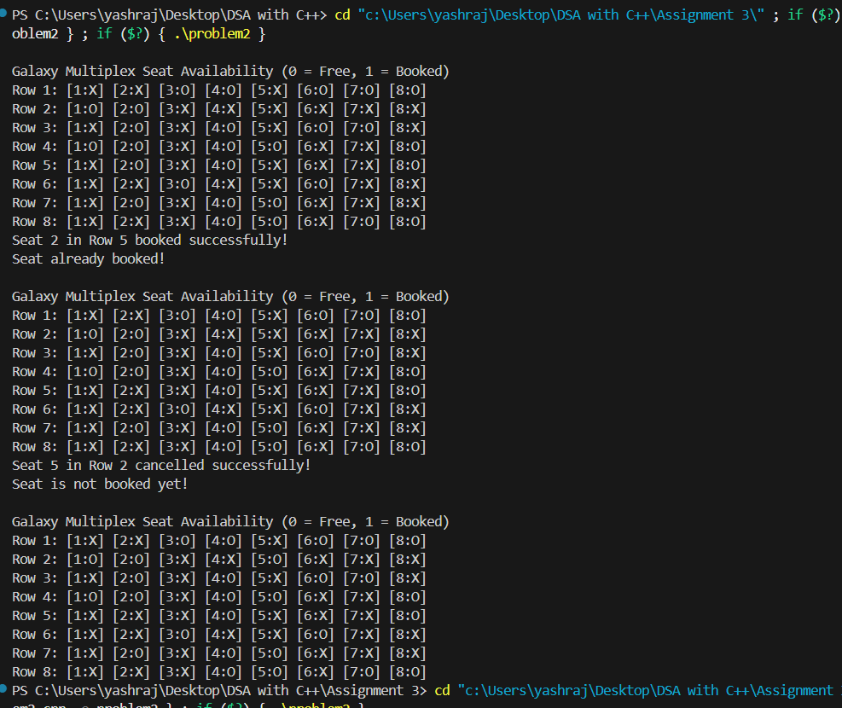

Problem 3 : Develop a C++ program to store and manage an appointment schedule for a single day. Appointments should be scheduled randomly using a linked list. The system must define the start time, end time, and specify the minimum and maximum duration allowed for each appointment slot.
The program should include the following operations:
a) Display the list of currently available time slots.
b) Book a new appointment within the defined time limits.
c) Cancel an existing appointment after validating its time, availability, and correctness.
d) Sort the appointment list in order of appointment times.
e) Sort the list based on appointment times using pointer manipulation (without swapping data values).

Code :
#include <iostream>
#include <string>
using namespace std;

class Node {
public:
int start_time; // appointment start time (in 24-hour format, e.g. 9 means 9:00)
int end_time; // appointment end time
bool booked; // true if slot is booked
string name; // person who booked
Node* next;

Node(int start, int end) {
start_time = start;
end_time = end;
booked = false;
name = "";
next = NULL;
}
};

class AppointmentSchedule {
Node* head;
int min_duration;
int max_duration;

public:
AppointmentSchedule(int start_day, int end_day, int min_dur, int max_dur) {
head = NULL;
min_duration = min_dur;
max_duration = max_dur;

// Create appointment slots dynamically (1-hour slots)
for (int time = start_day; time < end_day; time++) {
insertSlot(time, time + 1);
}
}

void insertSlot(int start, int end) {
Node* newNode = new Node(start, end);
if (!head) {
head = newNode;
} else {
Node* temp = head;
while (temp->next)
temp = temp->next;
temp->next = newNode;
}
}

void displaySlots() {
Node* temp = head;
cout << "\n------ APPOINTMENT SLOTS ------\n";
cout << "Time Slot\tStatus\t\tName\n";
while (temp) {
cout << temp->start_time << ":00 - " << temp->end_time << ":00\t";
if (temp->booked)
cout << "BOOKED\t\t" << temp->name << "\n";
else
cout << "AVAILABLE\t-\n";
temp = temp->next;
}
}

void bookAppointment(string person, int start, int end) {
if (end - start < min_duration || end - start > max_duration) {
cout << " Appointment duration not within allowed limits ("
<< min_duration << "-" << max_duration << " hour(s)).\n";
return;
}

Node* temp = head;
while (temp) {
if (temp->start_time == start && temp->end_time == end) {
if (temp->booked) {
cout << " Slot already booked by " << temp->name << ".\n";
return;
} else {
temp->booked = true;
temp->name = person;
cout << "✅ Appointment booked successfully for " << person << " at "
<< start << ":00 - " << end << ":00.\n";
return;
}
}
temp = temp->next;
}
cout << " Invalid time slot.\n";
}

void cancelAppointment(string person, int start, int end) {
Node* temp = head;
while (temp) {
if (temp->start_time == start && temp->end_time == end) {
if (!temp->booked) {
cout << " No appointment found in this slot.\n";
return;
}
if (temp->name != person) {
cout << " Appointment belongs to " << temp->name << ", not " << person << ".\n";
return;
}
temp->booked = false;
temp->name = "";
cout << "✅ Appointment cancelled successfully.\n";
return;
}
temp = temp->next;
}
cout << " Invalid slot entered.\n";
}

// Sort the list by swapping data (normal method)
void sortByTime() {
if (!head || !head->next)
return;

for (Node* i = head; i->next; i = i->next) {
for (Node* j = i->next; j; j = j->next) {
if (i->start_time > j->start_time) {
// swap data (not pointers)
swap(i->start_time, j->start_time);
swap(i->end_time, j->end_time);
swap(i->booked, j->booked);
swap(i->name, j->name);
}
}
}
cout << " Appointments sorted by time (data swapped).\n";
}

// Sort using pointer manipulation (no data swapping)
void sortByPointer() {
if (!head || !head->next)
return;

bool swapped;
do {
swapped = false;
Node** ptr = &head;
Node* a = head;
Node* b = head->next;

while (b) {
if (a->start_time > b->start_time) {
a->next = b->next;
b->next = a;
*ptr = b;
swapped = true;
}
ptr = &(a->next);
a = *ptr;
if (a)
b = a->next;
else
break;
}
} while (swapped);

cout << " Appointments sorted using pointer manipulation.\n";
}
};

// ============================ MAIN FUNCTION =============================

int main() {
int start_day = 9, end_day = 17; // 9 AM to 5 PM
int min_dur = 1, max_dur = 2;

AppointmentSchedule schedule(start_day, end_day, min_dur, max_dur);
int choice;
string name;
int start, end;

cout << "==============================\n";
cout << " APPOINTMENT SCHEDULING SYSTEM\n";
cout << "==============================\n";

while (true) {
cout << "\n------ MENU ------\n";
cout << "1. Display available slots\n";
cout << "2. Book new appointment\n";
cout << "3. Cancel appointment\n";
cout << "4. Sort appointments (by data swap)\n";
cout << "5. Sort appointments (by pointer manipulation)\n";
cout << "6. Exit\n";
cout << "Enter your choice: ";
cin >> choice;

switch (choice) {
case 1:
schedule.displaySlots();
break;
case 2:
cout << "Enter your name: ";
cin >> name;
cout << "Enter start time (e.g. 9 for 9:00): ";
cin >> start;
cout << "Enter end time (e.g. 10 for 10:00): ";
cin >> end;
schedule.bookAppointment(name, start, end);
break;
case 3:
cout << "Enter your name: ";
cin >> name;
cout << "Enter start time of appointment to cancel: ";
cin >> start;
cout << "Enter end time of appointment to cancel: ";
cin >> end;
schedule.cancelAppointment(name, start, end);
break;
case 4:
schedule.sortByTime();
break;
case 5:
schedule.sortByPointer();
break;
case 6:
cout << "Exiting system. Thank you!\n";
return 0;
default:
cout << " Invalid choice. Try again.\n";
}
}
}

OUTPUT :
PS C:\Users\yashraj\Desktop\DSA with C++> cd "c:\Users\yashraj\Desktop\DSA with C++\Assignment 3\" ; if ($?) { g++ problem3.cpp -o problem3 } ; if ($?) { .\problem3 }
==============================
APPOINTMENT SCHEDULING SYSTEM
==============================

------ MENU ------
1. Display available slots
2. Book new appointment
3. Cancel appointment
4. Sort appointments (by data swap)
5. Sort appointments (by pointer manipulation)
6. Exit
Enter your choice: 1

------ APPOINTMENT SLOTS ------
Time Slot Status Name
9:00 - 10:00 AVAILABLE -
10:00 - 11:00 AVAILABLE -
11:00 - 12:00 AVAILABLE -
12:00 - 13:00 AVAILABLE -
13:00 - 14:00 AVAILABLE -
14:00 - 15:00 AVAILABLE -
15:00 - 16:00 AVAILABLE -
16:00 - 17:00 AVAILABLE -

------ MENU ------
1. Display available slots
2. Book new appointment
3. Cancel appointment
4. Sort appointments (by data swap)
5. Sort appointments (by pointer manipulation)
6. Exit
Enter your choice: 2
Enter your name: Yashraj
Enter start time (e.g. 9 for 9:00): 10
Enter end time (e.g. 10 for 10:00): 11
Γ£à Appointment booked successfully for Yashraj at 10:00 - 11:00.

------ MENU ------
1. Display available slots
2. Book new appointment
3. Cancel appointment
4. Sort appointments (by data swap)
5. Sort appointments (by pointer manipulation)
6. Exit
Enter your choice: 2
Enter your name: Krushnarth
Enter start time (e.g. 9 for 9:00): 9
Enter end time (e.g. 10 for 10:00): 10
Γ£à Appointment booked successfully for Krushnarth at 9:00 - 10:00.

------ MENU ------
1. Display available slots
2. Book new appointment
3. Cancel appointment
4. Sort appointments (by data swap)
5. Sort appointments (by pointer manipulation)
6. Exit
Enter your choice: 3
Enter your name: Arham
Enter start time of appointment to cancel: 9
Enter end time of appointment to cancel: 10
Appointment belongs to Krushnarth, not Arham.

------ MENU ------
1. Display available slots
2. Book new appointment
3. Cancel appointment
4. Sort appointments (by data swap)
5. Sort appointments (by pointer manipulation)
6. Exit
Enter your choice: 4
Appointments sorted by time (data swapped).

------ MENU ------
1. Display available slots
2. Book new appointment
3. Cancel appointment
4. Sort appointments (by data swap)
5. Sort appointments (by pointer manipulation)
6. Exit
Enter your choice: 5
Appointments sorted using pointer manipulation.

------ MENU ------
1. Display available slots
2. Book new appointment
3. Cancel appointment
4. Sort appointments (by data swap)
5. Sort appointments (by pointer manipulation)
6. Exit
Enter your choice: 1

------ APPOINTMENT SLOTS ------
Time Slot Status Name
9:00 - 10:00 BOOKED Krushnarth
10:00 - 11:00 BOOKED Yashraj
11:00 - 12:00 AVAILABLE -
12:00 - 13:00 AVAILABLE -
13:00 - 14:00 AVAILABLE -
14:00 - 15:00 AVAILABLE -
15:00 - 16:00 AVAILABLE -
16:00 - 17:00 AVAILABLE -
------ MENU ------
1. Display available slots
2. Book new appointment
3. Cancel appointment
4. Sort appointments (by data swap)
5. Sort appointments (by pointer manipulation)
6. Exit
Enter your choice: 2
Enter your name: Arham
Enter start time (e.g. 9 for 9:00): 12
Enter end time (e.g. 10 for 10:00): 1
Appointment duration not within allowed limits (1-2 hour(s)).
Problem 4 : In the Second Year Computer Engineering class, there are two groups of students based on their favorite sports:
- Set A includes students who like Cricket.
- Set B includes students who like Football.
Write a C++ program to represent these two sets using linked lists and perform the following operations:
a) Find and display the set of students who like both Cricket and Football.
b) Find and display the set of students who like either Cricket or Football, but not both.
c) Display the number of students who like neither Cricket nor Football.

CODE :
#include<iostream>
using namespace std;

struct Node
{
string name;
Node* next;
};

class SYCM
{
Node* head;
public:
SYCM()
{
head=NULL;
}

void insert(string s)
{
Node* n=new Node();
n->name=s;
n->next=head;
head=n;
}
bool search(string s)
{
Node* temp=head;
while(temp){
if(temp->name==s)
return true;

temp=temp->next;
}
return false;
}

Node* getHead()
{
return head;
}

void display()
{
Node* temp=head;
while(temp)
{
cout<<temp->name<<" ";
temp=temp->next;
}
cout<<endl;
}
};

int main()
{
SYCM cricket , football;
int total,n1,n2;
cout<<"Enter total number of Students : ";
cin>>total;

cout<<"Enter the number of Students who likes cricket: ";
cin>>n1;
cout<<"Enter names:";
for(int i=0;i<n1;i++)
{
string s;
cin>>s;
cricket.insert(s);
}

cout<<"Enter the number of students who likes football: ";
cin>>n2;
cout<<"Enter Names:";
for(int i=0;i<n2;i++)
{
string s;
cin>>s;
football.insert(s);
}

cout << "\nStudents who like Cricket: ";
cricket.display();
cout << "\nStudents who like Football: ";
football.display();

//(a) Students who likes both Cricket and football (Intersection)
cout<<"\nStudents who likes both Cricket and football :";
Node* tem=cricket.getHead();
while(tem)
{
if (football.search(tem->name))
{
cout<<tem->name<<" ";
}
tem=tem->next;
}

//(b) Students who like either Cricket or Football, but not both. (Symmetric Difference)
cout<<"\nStudents who like either Cricket or Football, but not both: ";

Node* temp=cricket.getHead();
while (temp)
{
if(!football.search(temp->name))
{
cout<<temp->name<<" ";
}
temp=temp->next;
}
Node* temp2=football.getHead();
while(temp2)
{
if(!cricket.search(temp2->name))
{
cout<<temp2->name<<" ";
}
temp2=temp2->next;
}

//The number of students who like neither Cricket nor Football.
int count=0;
Node* t1=cricket.getHead();
while(t1)
{
count++;
t1=t1->next;
}

Node* t2=football.getHead();
while(t2)
{
if(!cricket.search(t2->name))
{
count++;
}
t2=t2->next;
}

cout<<"\nNumber of Students who neither like cricket or football :"<<total-count;
return 0;
}

OUTPUT :
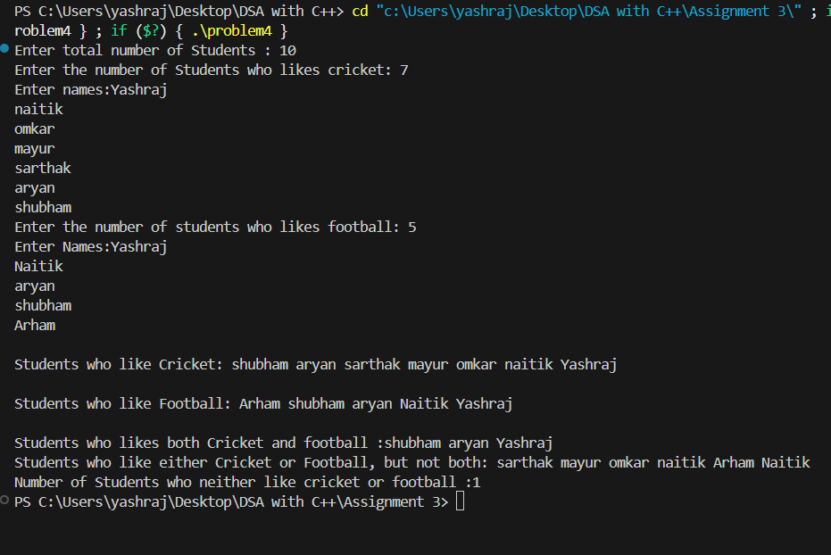
Problem 5 : Write a C++ program to store a binary number using a doubly linked list. Implement the following functions:
a) Calculate and display the 1’s complement and 2’s complement of the stored binary number.
b) Perform addition of two binary numbers represented using doubly linked lists and display the result.
CODE :
#include <iostream>
using namespace std;

// Doubly linked list node
class Node {
public:
int data; // will store binary digit (0 or 1)
Node* prev;
Node* next;

Node(int val) {
data = val;
prev = next = NULL;
}
};

// Binary number using Doubly Linked List
class BinaryNumber {
public:
Node* head;
Node* tail;

BinaryNumber() {
head = tail = NULL;
}

// Function to insert a binary digit at the end
void insertBit(int bit) {
Node* newNode = new Node(bit);
if (!head) {
head = tail = newNode;
} else {
tail->next = newNode;
newNode->prev = tail;
tail = newNode;
}
}

// Display the binary number
void display() {
Node* temp = head;
while (temp) {
cout << temp->data;
temp = temp->next;
}
cout << endl;
}

// Create and return 1’s complement
BinaryNumber onesComplement() {
BinaryNumber result;
Node* temp = head;
while (temp) {
result.insertBit(temp->data == 0 ? 1 : 0);
temp = temp->next;
}
return result;
}

// Create and return 2’s complement
BinaryNumber twosComplement() {
BinaryNumber oneComp = onesComplement();
BinaryNumber result;

Node* temp = oneComp.tail;
int carry = 1;

// Traverse from LSB to MSB
while (temp) {
int sum = temp->data + carry;
result.insertBit(sum % 2);
carry = sum / 2;
temp = temp->prev;
}
if (carry == 1)
result.insertBit(1);

// Reverse to correct order
result.reverse();
return result;
}

// Reverse the linked list (used for correct display order)
void reverse() {
Node* curr = head;
Node* temp = NULL;
while (curr) {
temp = curr->prev;
curr->prev = curr->next;
curr->next = temp;
curr = curr->prev;
}
if (temp)
head = temp->prev;
}

// Add two binary numbers and return result
static BinaryNumber add(BinaryNumber b1, BinaryNumber b2) {
BinaryNumber result;
Node* t1 = b1.tail;
Node* t2 = b2.tail;

int carry = 0;
while (t1 != NULL || t2 != NULL || carry != 0) {
int bit1 = (t1 ? t1->data : 0);
int bit2 = (t2 ? t2->data : 0);
int sum = bit1 + bit2 + carry;

result.insertBit(sum % 2);
carry = sum / 2;

if (t1) t1 = t1->prev;
if (t2) t2 = t2->prev;
}

result.reverse();
return result;
}
};

// Main function
int main() {
BinaryNumber num1, num2;

cout << "Enter first binary number: ";
string bin1;
cin >> bin1;
for (char c : bin1)
num1.insertBit(c - '0');

cout << "\nStored Binary Number 1: ";
num1.display();

cout << "1's Complement: ";
BinaryNumber oneComp = num1.onesComplement();
oneComp.display();

cout << "2's Complement: ";
BinaryNumber twoComp = num1.twosComplement();
twoComp.display();

cout << "\nEnter second binary number: ";
string bin2;
cin >> bin2;
for (char c : bin2)
num2.insertBit(c - '0');

cout << "\nStored Binary Number 2: ";
num2.display();

cout << "Addition Result: ";
BinaryNumber sum = BinaryNumber::add(num1, num2);
sum.display();

return 0;
}

OUTPUT :
